TUTORIAL – 12
AI-Powered Software Testing
Project Name | AI-Powered Software Testing
Module Name | Login and Authentication (AI-Assisted Software Testing)
Test Case ID | TC012
Tester Name | Vidhi patel
Application Under Test | SauceDemo (https://www.saucedemo.com/)
AI Tool | Generative AI
Automation Tool | Selenium WebDriver with Python 3.x, PyCharm, Google Chrome
Execution Date | 29/10/2026

AI Prompt
Analyze this software requirement:
A registered user should be able to log in using a valid username and password. Invalid credentials should be rejected and an appropriate error message should be displayed.

Generate:
1. Positive test cases
2. Negative test cases
3. Test data
4. Expected results
5. Regression test scenarios
6. Possible defect-prone areas
7. Selenium Python automation code

The final Selenium code should be executable in PyCharm.

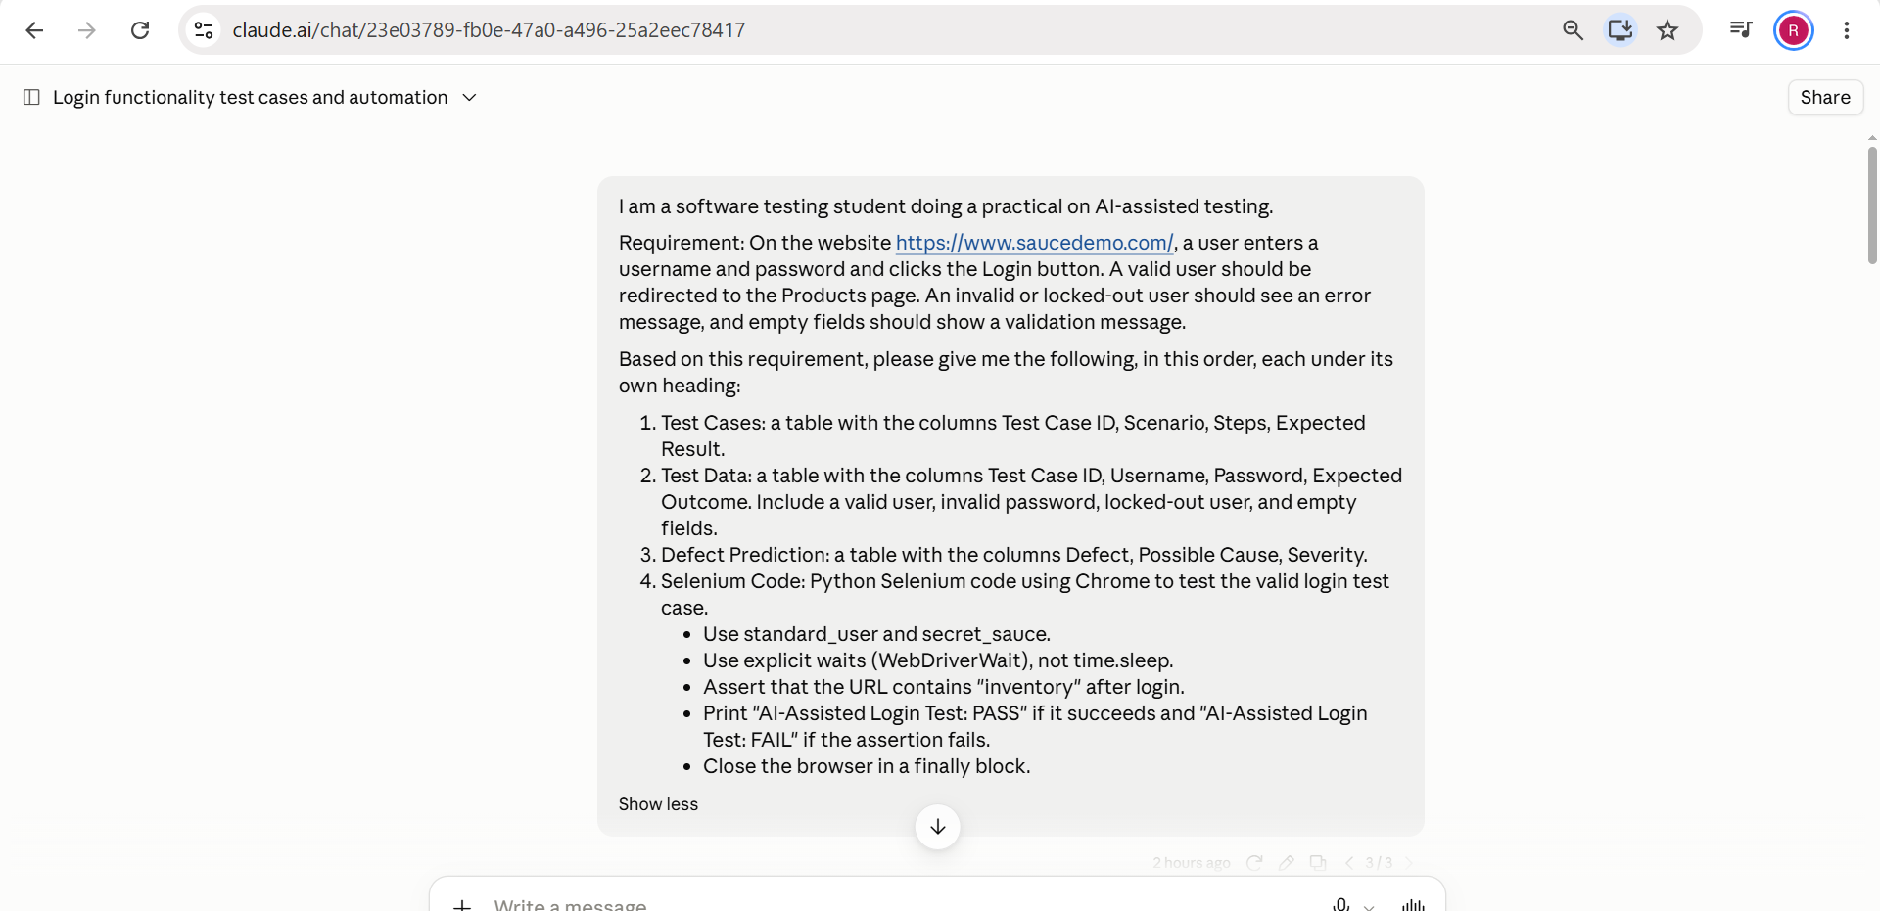
Figure 1: Prompt entered in the Generative AI tool

AI-Generated Test Cases
Test Case ID | Scenario | Test Data | Expected Result
TC-12-01 | Valid Login | standard_user / secret_sauce | Login successful
TC-12-02 | Invalid Password | standard_user / wrong123 | Error displayed
TC-12-03 | Invalid Username | wrong_user / secret_sauce | Error displayed
TC-12-04 | Empty Username | Blank / secret_sauce | Validation message
TC-12-05 | Empty Password | standard_user / Blank | Validation message
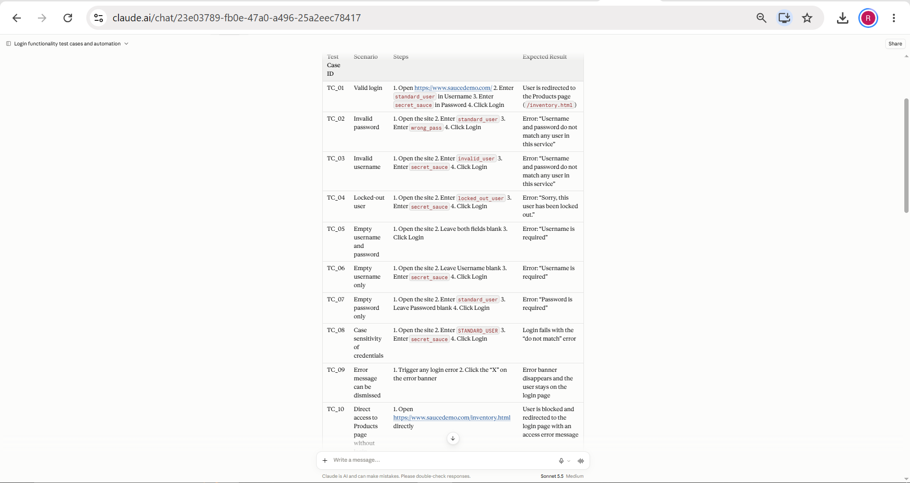
Figure 2: Test cases generated by the AI tool

AI-Generated Test Data
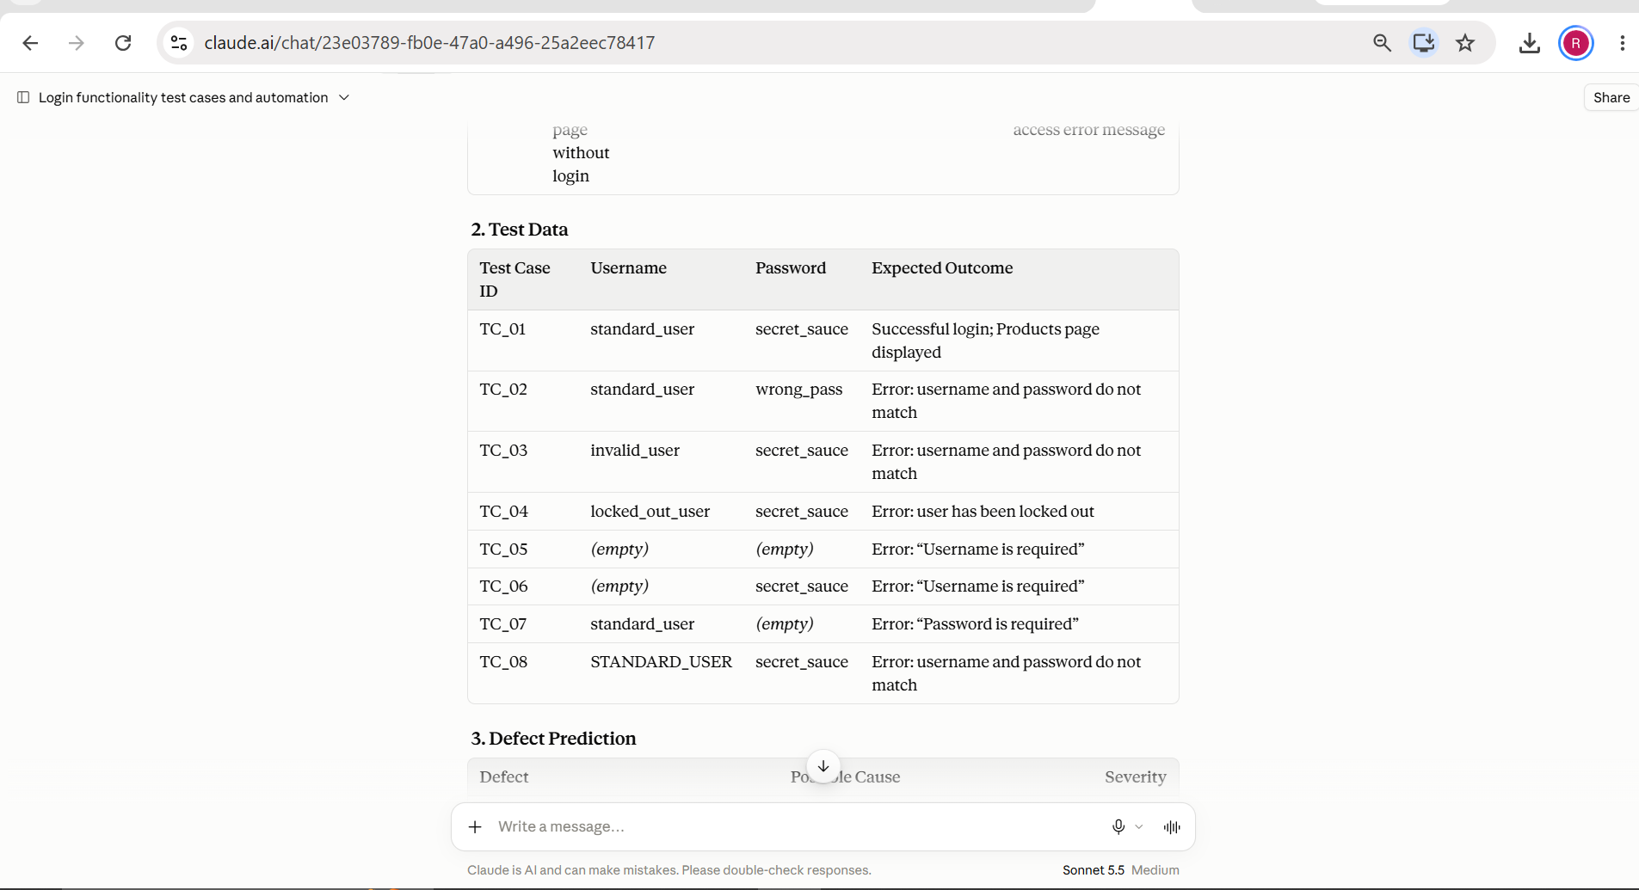
Figure 3: Test data generated by the AI tool

AI-Based Requirement Analysis
Requirement | Testable Scenario
Valid user can log in | Valid Login
Invalid credentials rejected | Negative Login
Error should be displayed | Error Message Validation
Login must use username/password | Form Validation
Existing login must continue working | Regression Testing

AI-Based Defect Prediction
The AI tool was asked to analyze the login module and identify defect-prone areas based on input validation, authentication, error handling, session management and user interaction, with a reason for each prediction. The suggestions were then reviewed for technical reasonableness.
Area | Possible Defect / Reason | Severity | Reasonable?
Input validation | Empty or whitespace-only fields accepted or shown the wrong message | Medium | Yes
Authentication | Wrong credentials or locked-out user logged in due to faulty check | High | Yes
Error handling | Missing or unclear error message for invalid login | Medium | Yes
Session management | Products page reachable without logging in, or session not cleared | High | Yes
User interaction | Login button or Enter key not responding; field focus problems | Low | Yes

AI-Generated and Reviewed Selenium Code
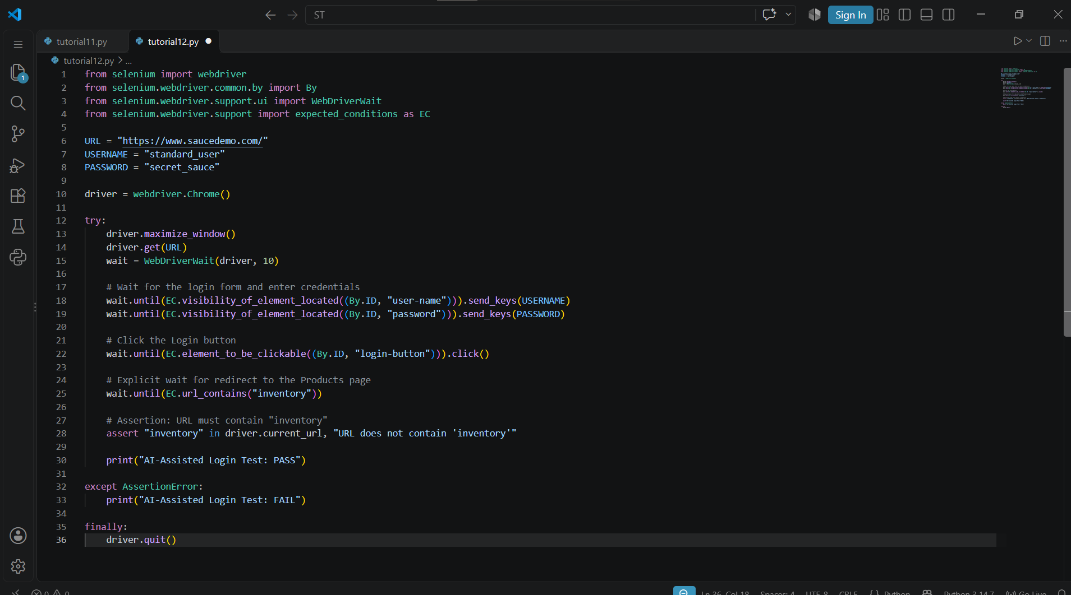
Figure 4: Selenium code generated by the AI tool
The AI output was reviewed for test cases, test data, expected results, locators, Python syntax, assertions and error handling, and the corrected code was run in PyCharm as ai_login_test.py.

Final Reviewed Source Code
from selenium import webdriver
from selenium.webdriver.common.by import By
from selenium.webdriver.support.ui import WebDriverWait
from selenium.webdriver.support import expected_conditions as EC

driver = webdriver.Chrome()
driver.maximize_window()

try:
driver.get("https://www.saucedemo.com/")
wait = WebDriverWait(driver, 10)

username = wait.until(
EC.visibility_of_element_located((By.ID, "user-name"))
)
password = driver.find_element(By.ID, "password")
login_button = driver.find_element(By.ID, "login-button")

username.send_keys("standard_user")
password.send_keys("secret_sauce")
login_button.click()

wait.until(EC.url_contains("inventory"))
assert "inventory" in driver.current_url

print("AI-Assisted Selenium Test: PASS")
print("Requirement Validation: PASS")

except AssertionError:
print("AI-Assisted Selenium Test: FAIL")

finally:
driver.quit()

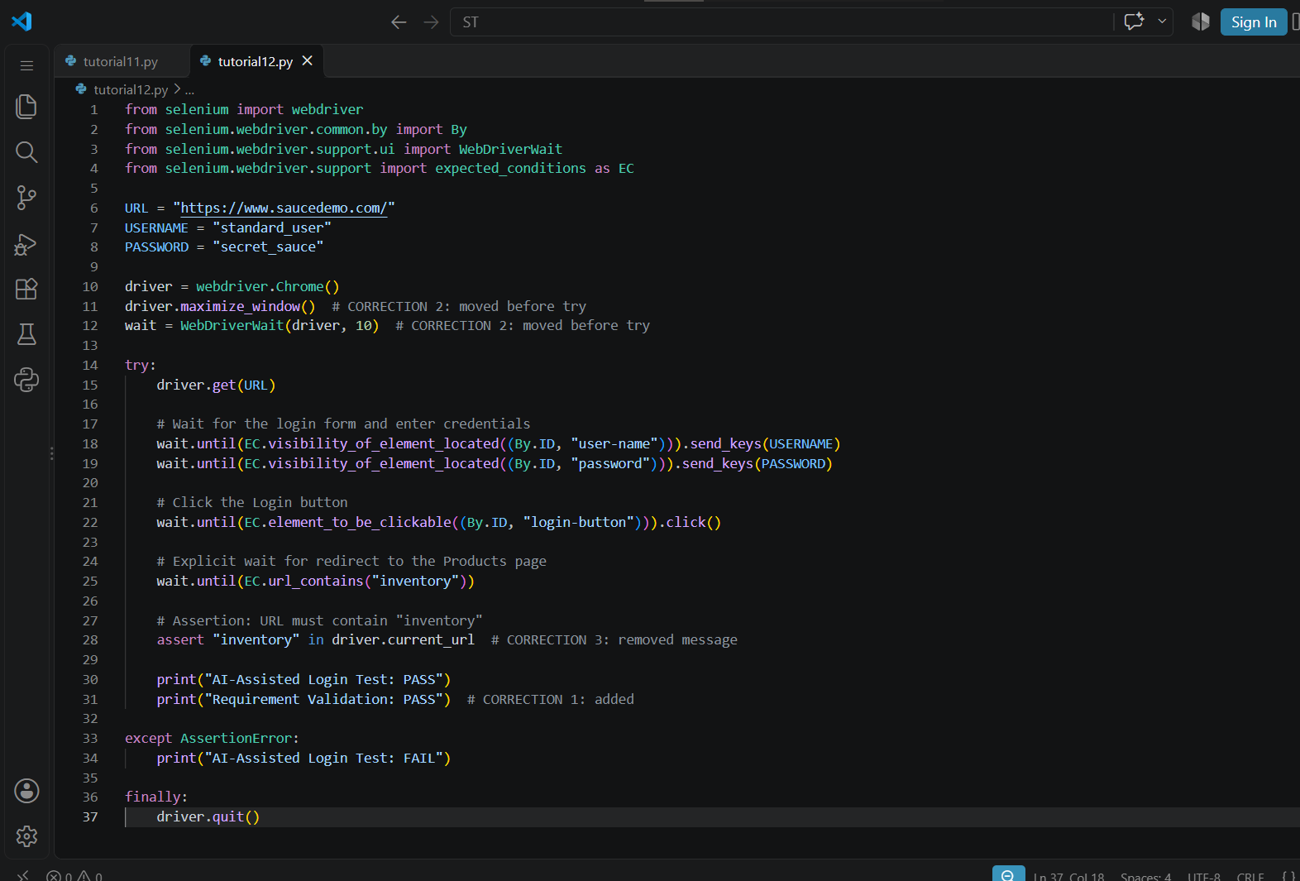

Browser Output
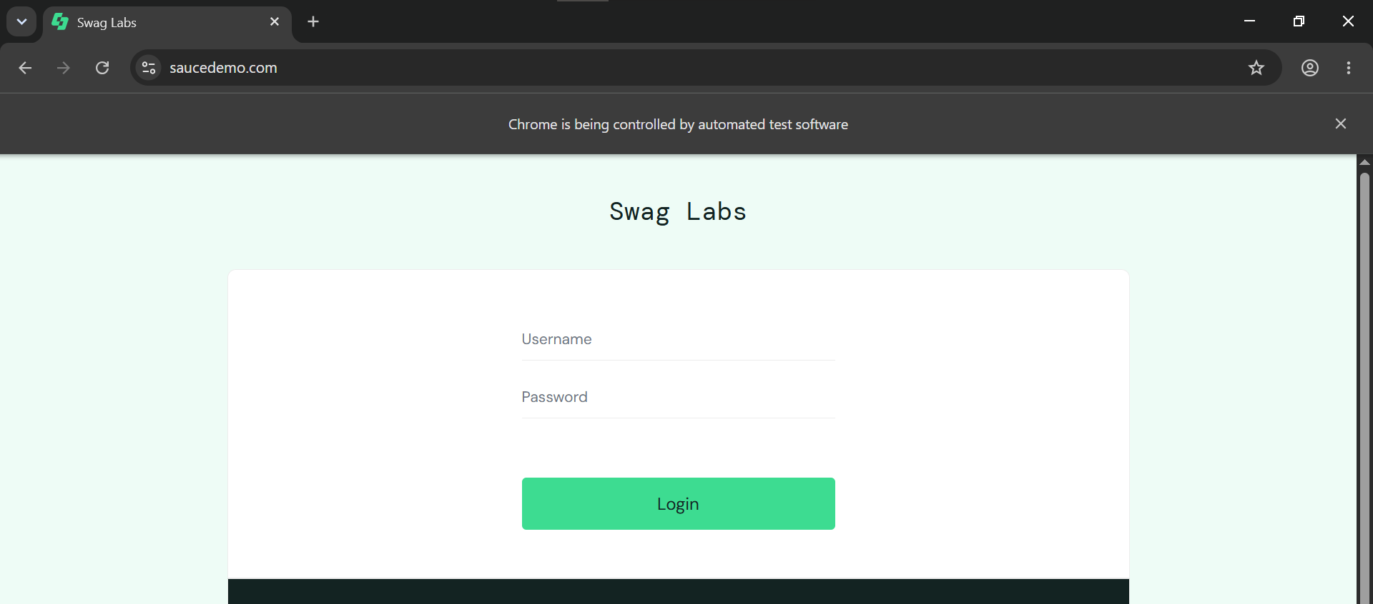
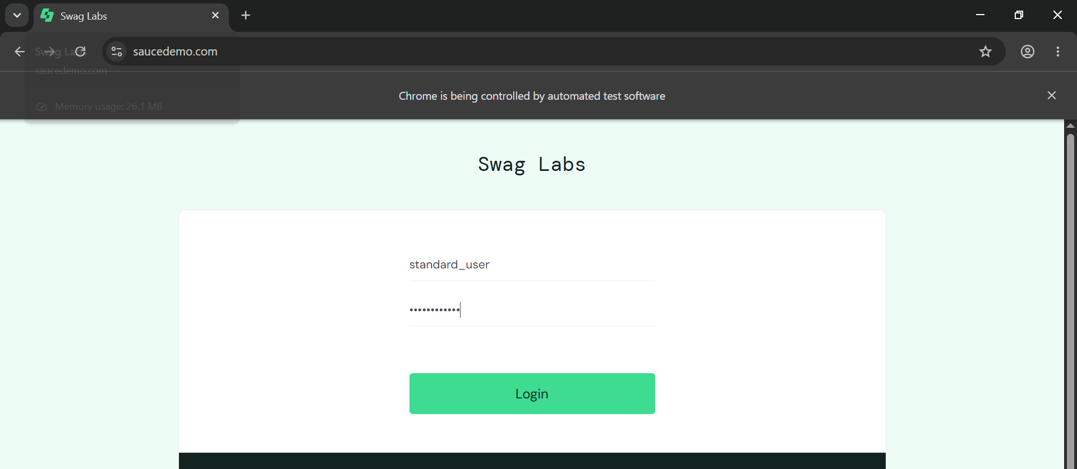
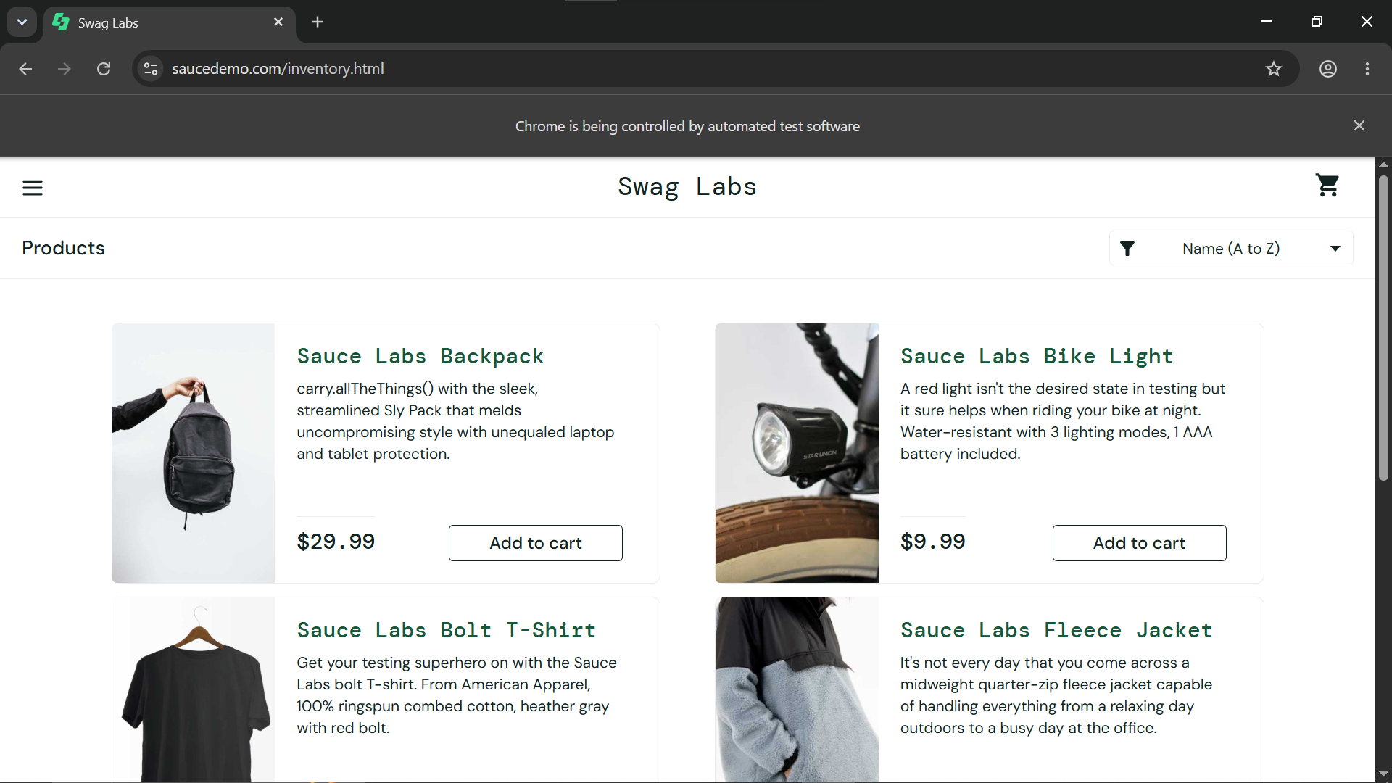

Console Output
